Forum: The General Assembly One – Disarmament and International Security
Issue: Forestalling the acquisition of nuclear weapons by rogue states and sub-national groups
Student Officer: Garrett Lee
Position: President of the General Assembly
Introduction
For most people, disarmament and international security seem distant. To this end, world citizens should be grateful for the governments and officials keeping their nations safe. Despite efforts, various leaders have exerted power over others with nuclear weapons. Today, nuclear weapons are told to have the power to destroy the whole entire planet; thus, large military activities should be monitored to attempt to prevent another world war.
In light of this pressing issue, this report seeks to first retrace steps to the World Wars, look at the current standing of nuclear weapons around the world today, then provide suggestions to alleviate the situation at hand.
Definition of Key Terms

Rogue states
A nation or state regarded as breaking international law and posing a threat to the security of other nations.
Non-proliferation Treaty (NPT)
The Non-proliferation Treaty was initiated by the United Nations in 1968 in order to reduce the threats posed by nuclear weapons. Effective in 1970, the treaty asks the International Atomic Energy Agency (IAEA) to dispatch safeguards verifying that each nation complies with the details described in the treaty.
Nuclear-Weapon States (NWS)
There are five nuclear-weapon states that are officially approved to possess nuclear weapons by the NPT: China, France, Russia, the United Kingdom, and the United States. Although the treaty recognizes the possession of the weapons, it does not allow any of the five countries to further develop nuclear weapons for offensive purposes.

History

After World War II
The two atomic bombs in 1945 were disastrous. However, they did not stop countries from developing more weapons. After World War II, tensions between the United States and the Soviet Union (the USSR) worsened. With the United States and the USSR quickly developing nuclear weapons, many nations sided with either the United States or the USSR. Although there were third-world countries without allegiances to either nation, they were not completely safe from the nuclear power struggle. The Cold War exemplified the power and fear that nuclear weapons bring.

Development after World War II
Disturbed by global insecurity, various other nations began to develop nuclear power as well. For the next two decades, the following nations acquired the technology: United Kingdom (1952), France (1960), and China (1964). In response to the rapid spread of the nuclear technology, several governments “negotiated the nuclear [NPT] and the Comprehensive Nuclear Test Ban Treaty (CTBT) in 1996” (Davenport). With around fifty nations signing the NPT on July 1, 1968, other countries joined in the efforts. Since then, countries that signed the NPT reduced the nuclear stockpile in their respective armies.
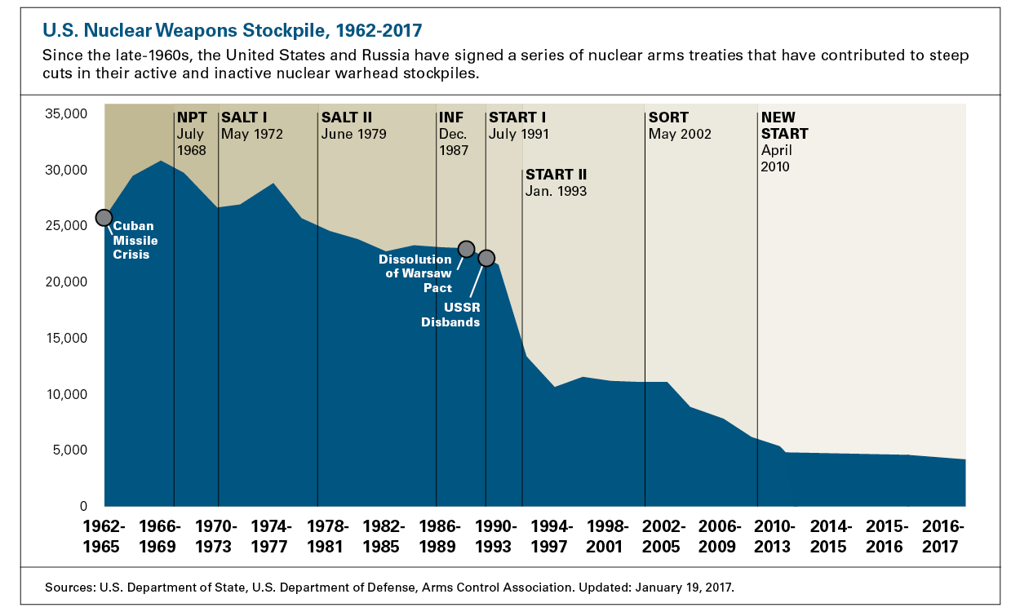
Figure 1 U.S. Nuclear Weapons Status Past to Present

Nuclear standings today

With most countries withdrawing from nuclear weapons or relying on other types of combat options, the world may seem safer today. However, some countries may still violate such peace. North Korea, although part of the NPT in the past, withdrew from the NPT twice: in 1993, and also in 2003. Since the second withdrawal, North Korean leaders have conducted nuclear tests. With U.S. President Trump and South Korean President Moon Jae-in carrying on with the THAAD missile system, the tensions between China, North and South Korea are worsening. In addition, there are four other UN states that have never been a party to the treaty: India, Israel, Pakistan, and South Sudan.
Key Issues

Nuclear Terrorism
The recent interactions between North Korea and the US beg the questions: will nuclear power cause another world war? Can any nuclear states and terrorist groups use nuclear weapons to target civilians? The fact that any nuclear weapon developed today can destroy the whole planet is very disturbing, as is the potential threat that any single leader can pose to the entire world.

Loopholes in the NPT
The NPT is not a permanent solution as there are several tentative conclusions that are not clear. For example, Article VI of the treaty obligates all parties, particularly the nuclear-weapon states, to pursue nuclear disarmament. The main issue with this specific portion is that the commitment contains no deadline by which nuclear disarmament must be complete; thus, no nuclear states have completely worked towards the goal.

Health and environmental effects
One of the topics that nuclear states avoid is the effect that nuclear weapons have in their surroundings. Though the use of nuclear weapons near the end of World War II posed disastrous consequences for Japanese citizens, modern weapons are far more powerful. For example, “a regional nuclear conflict between India and Pakistan could create a smoke layer around the planet that would block out 10% of the incoming sunlight” (Effects on Environment). Governments need to consider the environmental impacts that nuclear weapons can bring.

Major Parties Involved and Their Views

The Nuclear-Weapon States (China, France, Russia, United Kingdom, and the United States)
The purpose of possessing nuclear weapons is two-fold: for national defense purposes and to exert power over other parties. It seems selfish that these states do not denuclearize for their citizens’ safety. However, not having nuclear weapons while opposing parties do is a huge disadvantage. Therefore, although nuclear-weapon states believe in making the world safer, they will not denuclearize completely unless all other nations do so.

North Korea
North Korea seems to be the heart of the debate when it comes to nuclear weapons, as leader Kim Jung-un has been authorizing nuclear tests. Recently, North Korea’s ties with the United States have become strained and U.S. President Donald Trump is strongly suggesting sanctions to discourage Kim from continuing nuclear tests. Currently, North Korea does not seem to be interested in pausing these tests. In addition, the THAAD missile system was launched in South Korea in 2017, leading to more tensions between North Korea, the United States, South Korea, and China.
Timeline of Relevant Resolutions, Treaties and Events
Date | Description of event
August 1945 | Two atomic bombs, Little Boy and Fat Man, are dropped in Hiroshima and Nagasaki respectively
July 1, 1968 | The first group of nations sign the Non-proliferation Treaty (NPT)
March 5, 1970 | The NPT becomes effective
October 2006 | North Korea carries out nuclear tests
2017 | THAAD missile system launches in South Korea
Evaluation of Previous Attempts to Resolve the Issue
The NPT has been somewhat effective for the past several decades. With the NWS reducing the number of nuclear arsenals from 70,000 during the Cold War to 14,900 in 2017, there seems to be less reliance on nuclear weapons in general. This is to prevent countries from questioning the NPT or withdrawing from the treaty to develop nuclear weapons. The United States and Russia in particular have cooperated in order to reduce the number. Other countries have created organizations and committees, such as the International Commission on Nuclear Non-Proliferation and Disarmament (ICNND) and the Weapons of Mass Destruction (WMD) Commission, to communicate the severity of such weapons in order to spread more awareness.
Some countries in the Middle East are suspected to have nuclear missiles. Not only were those nuclear activities not communicated, they were also not authorized. Currently, the United Nations has passed resolutions to discourage these nations from pursuing nuclear weapons.
Possible Solutions

Negotiations

When dealing with a pressing global issue, effective negotiations are the first responses (the UN support peaceful resolutions, not violence). World leaders should identify what each party wants. In the case of North Korea, as power is a crucial component behind the weapons, world leaders could create incentives to catch North Korea’s attention.

Incentives and sanctions
Sometimes negotiations are not effective because either no middle ground exists or the relevant leaders simply will not meet. Then, non-governmental committees can take a more direct approach: reducing trade and communication. The efficiency of this method depends on the response. In the initial stages, nations rely on incentives, and in extreme situations, the general consensus is to use sanctions. The question posed is: when are incentives and sanctions needed?
Bibliography
Bailey, Chelsea. “How Many Nuclear Weapons Exist? U.N. Calls for Total Elimination of Nukes.” NBCNews.com, NBCUniversal News Group, 26 Sept. 2017, www.nbcnews.com/news/us-news/how-many-nuclear-weapons-exist-united-nations-calls-total-elimination-n804721.
Davenport, Kelsey. “Nuclear Weapons: Who Has What at a Glance.” Arms Control Association, Oct. 2017, www.armscontrol.org/factsheets/Nuclearweaponswhohaswhat.
“Dozens Injured in South Korea Protest against US Anti-Missile THAAD System.” CNBC, CNBC, 7 Sept. 2017, www.cnbc.com/2017/09/07/us-adds-launchers-to-thaad-as-dozens-hurt-in-south-korea-protests.html.
“Nuclear Disarmament Resource Collection.” Nuclear Threat Initiative - Ten Years of Building a Safer World, 3 Apr. 2017, www.nti.org/analysis/reports/nuclear-disarmament/.
“Nuclear Weapons: Issues.” Nuclear Files, www.nuclearfiles.org/menu/key-issues/nuclear-weapons/issues/.
Shah, Anup. “North Korea and Nuclear Weapons.” Global Issues, 29 Oct. 2006, www.globalissues.org/article/698/north-korea-and-nuclear-weapons.
“Treaty on the Non-Proliferation of Nuclear Weapons.” United Nations, United Nations, www.un.org/disarmament/wmd/nuclear/npt/.
Wikipedia contributors. "List of parties to the Treaty on the Non-Proliferation of Nuclear Weapons." Wikipedia, The Free Encyclopedia. Wikipedia, The Free Encyclopedia, 8 Nov. 2017. Web. 15 Nov. 2017.

