Forum: Advisory Panel on the Question of Syria, Iraq and Iraqi Kurdistan
Issue: Protecting the internally displaced Yazidi and other ethnic and religious minorities in Iraq
Student Officer: Jessica Choi
Position: President
Introduction
“Iraq is a graveyard for ethnic and religious minorities. We never expected another Holocaust would happen. But it did,” expressed Sherzhad Memsani, one of the last remaining Jewish people in Iraq. With the rise of the Islamic State of Iraq and the Levant (ISIS or ISIL) and the breakout of the Iraq Civil War, Iraqi ethnic minorities are experiencing persistent human rights violations to this day.
Out of all the ethnic minorities in northern Iraq that suffered the Islamic State of Iraq and Levant’s atrocities, the Yazidis had the biggest blow. The Yazidis are monotheists who believe in a peacock angel and practice an ancient gnostic faith. Viewing the Yazidis’ god as Lucifer, the most malevolent demon to the Islamic religion, ISIL and followers of Islam call the Yazidis the “devil worshippers.” This belief justified ISIL and Suddam Hussein’s persecution of Yazidis. Once, there was approximately 1.5 million Yazidi people, but now only 700,000 survived and are still on their run.
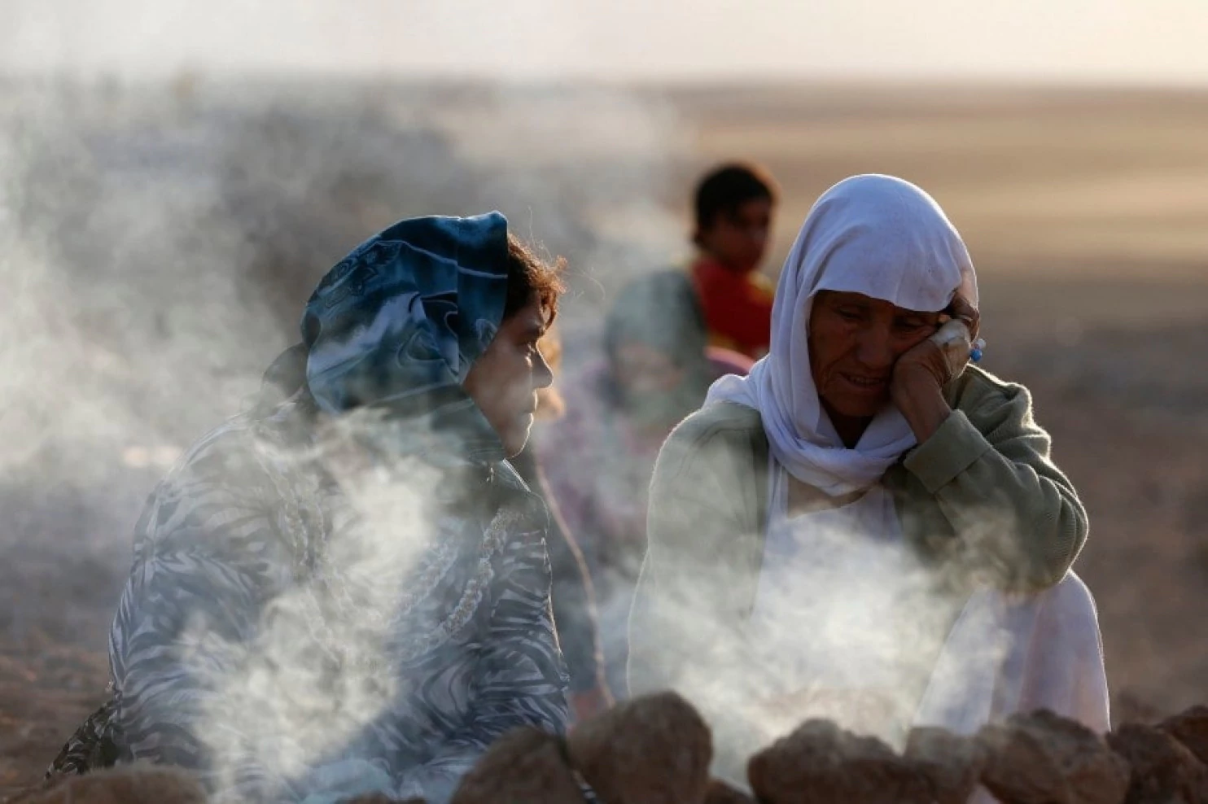
Internally Displaced Yazidis, who fled from violence in Sinjar, at a refugee camp.
That's not to say that ISIL isn't targeting the Yazidis only. Other religious and ethnic minorities in northern Iraq have also been the victims of ISIL jihadism. About ten percent of Iraq’s entire population is made up of minority groups—including Turkmen, Assyrians, Baha’is, Faili Kurds, Jews, and Palestinians; yet they have been subjected to endless violence and terror, forcing some groups to turn nearly extinct. As the primary targets of political, economic, and religious violence, the ethnic minorities are subjected to rape, torture, murders, abductions, and destruction of property. As chaos and fear among the Iraqi minority population deepens, the government and international aid agencies are scrambling to meet their urgent humanitarian needs. However, beyond the immediate humanitarian needs of the displaced are longer-term questions about what is and will happen to minorities in Iraq. The UN is tasked to stop the ongoing cycle of violations of Iraq’s minority rights as well as to ensure the protection of minorities who are currently either internally displaced or in refuge.
Throughout the debate, consider some questions to tackle the persecutions and displacements of Yazidis and other ethnic minorities:
- What are the short and long-term solutions to protect the ethnic and religious minority groups in Iraq?
- In what ways should the Iraqi government create a climate where Iraq’s ancient and diverse cultures of minorities are integrated?
- How will the UN guarantee the protection of fundamental minority rights by the Iraqi government?
- Through what measures will the UN, Non-Governmental Organizations (NGOs), Iraq, and neighboring countries secure the refugees and internally displaced persons who belong to Iraq’s minority groups?

Definition of Key Terms

Yazidis

A religious minority group that has been one of the primary victims of ethnic cleansing in Iraq. Majority consider themselves as Kurdish, but the Yazidis are religiously distinct from Iraq's Kurdish population. Yazidism is religiously categorized as syncretism, which means it combines different elements of Islam, Christianity, Judaism and Zoroastrianism. The Yazidis isolate themselves by rarely intermarrying with other ethnic groups and resisting religious conversions; but they have branches in Turkey, Syria, Iran, and Germany.

Kurdish Regional Government (KRG)
The KRG earned their regional autonomy in northern Iraq in 1991 when the UN Security Council P5 members US, UK, and France gave them the rights to govern the Kurdish Autonomous Republic.

Iraqi Turkmen
The Iraqi Turkmen are an ethnic minority group in Iraq who shares a Turkish ethnicity.

Iraqi Assyrians
The Iraqi Assyrians are an ethnic, religious, and linguistic minority group who make up about 0.5 percent of the Iraq people. With their heritage from the Assyrians and Babylonians during the ancient Mesopotamian era, the Assyrians preserve Akkadian language. Most Assyrians practice Christianity.

Internally Displaced Persons (IDPs)
IDPs are people who are forced to escape their homes but are still within their country’s borders. It is important to not categorize IDPs simply as refugees. While they may have fled for similar reasons, IDPs stay within their own country and remain under the protection of its government—whether or not the government is the reason behind their displacement, making the IDPs the more vulnerable than the refugees.

Refugees
Refugees are those who have been forced to flee their country and have already crossed their country’s borders.
Genocide
The UN defines genocide as any act committed with intent to destroy, in whole or in part, a national, ethnic, racial, or religious group.
Ethnic Cleansing
The systematic forced removal of ethnic or religious groups from a given territory by a more powerful ethnic group, often with the intent of making the area more homogenous ethnically.
Arabization
Arabization refers to the process of acquiring territories that are controlled by the non-Arab people. The aim of Arabization is the assimilation of Arabic culture and identity to non-Arab populations.
Sinjar
Sinjar is the city Yazidis call home. However, Sinjar is located along with many border regions at the edge of the KRG, thereby remaining as an area of dispute between the Kurds and the Iraqi central government.
Kirkuk
Kirkuk is a northern Iraqi city with diverse demographics populated with Kurds, Turkmen, Arabs, and Assyrians. The ethnic groups have long maintained their territorial disputes to this city by arguing their historical connections to support their stances. Kirkuk was once controlled by the KRG, but after the 2017 Referendum on Iraqi Kurds’ Independence, Baghdad government seized back the city.
History

Ottoman Era

Persecutions of the ethnic minorities have a long history in Iraq. The Ottoman Empire was governed by Muslim Turks and administered non-Muslims as second-class citizens by refusing to uphold their fundamental civil rights and requiring them to pay extra taxes. Under the Ottoman era, the Yazidis were forced to convert to Islam and were persecuted 72 times in the 18th and 19th centuries. The Ottoman Empire is also responsible for the Armenian Genocide where they systematically exterminated 1.5 million Armenians, an ethnic minority group of the Ottoman empire.

It is also during the rule of Ottoman Empire the Turkmen migrated into Iraq. The Turkmen, however, mostly maintained their administrative and business social status. Their predominant presence in the Kirkuk in northern Iraq established the city as the center of Iraqi Turkmen community.

Suddam Hussein’s Regime (1979-2003)
In the late 20th century, Iraqi dictator Saddam Hussein massacred the Kurds in northern Iraq through the Al-Anfal Campaign, also known as Hussein’s “Arabization.” Though the Campaign was against the Kurdish population in norther Iraq, it greatly affected different groups of ethnic minorities with about 100,000 people pushed out of oil-rich territories between Mosul and Kirkuk. Because Yazidis are ethnically Kurds, they were turned into scapegoats of Hussein’s Al-Anfal Campaign. Hussein launched campaigns to destroy Yazidis’ villages, disrupt their rural way of life, and relocate them in cities.
As for the Turkmen, they have not been allowed the same privileges as they had under the Ottoman rule. Instead, they were persecuted by the Iraqi government as witnessed by the series of massacres—Massacre of 4 May 1924 and Kirkuk Massacre of 1959—against the ethnic group. Under Hussein, thousands of Turkmen were relocated from northern Iraq and replaced by Arab for Arabization.

Iraq Insurgency (2003-2011)

2003 US Invasion in Iraq

Operation Iraqi Freedom combat operations came to an end in May 1, 2003, yet situations for minority groups only worsened. Detailed numbers of savage assaults—murder, torture, abductions, threats, destroying properties—continued to increase, terrorizing the minority population in Iraq. During this period, powerful and dangerous Islamic radical groups such as Al-Qaeda began spreading their influence in Iraq and began ethnic and religious cleansing of Christians. About 1.4 million Assyrians in Iraq and more than 1 million unarmed Christian civilians were forced out of their homelands. Due to this persecution, Iraq is ranked third after North Korea and Somalia as the most dangerous place for Christians.

Iraq Civil War

After the US military forces from Iraq withdrew, Sunni militant groups became increasingly violent towards the Iraqi government and eventually began the Iraqi Civil War. ISIL attempts to instill an Islamic state within Iraq by enforcing strict Sharia law and aggressively interfering with the Shia-led Iraqi government and its endeavor at establishing a stable, self-sustaining democracy corresponding with America’s endorsement. A past UN effort to resolve this conflict is their extension of the mandate of the United Nations Assistance Mission for Iraq (UNAMI) and an emphasis on the stabilization of Iraq following ISIL’s acts of terrorism, brought forth by Resolution 2299.

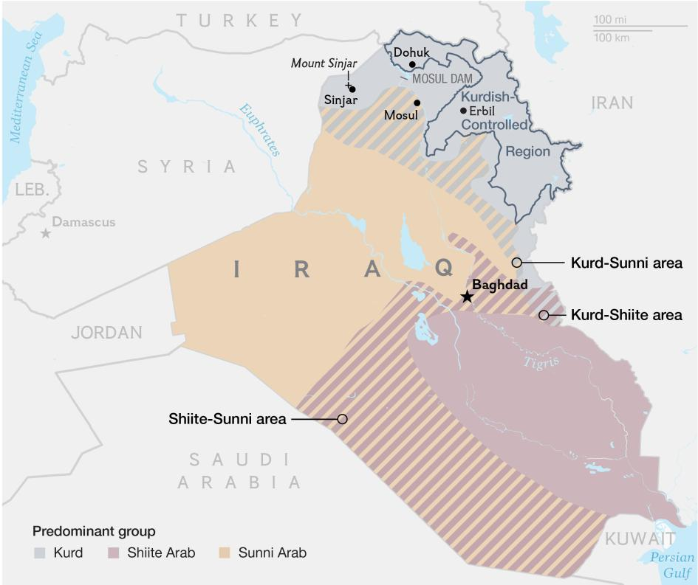

The Yazidis fled from their hometown Sinjar located in northern Iraq, mainly controlled by the KRG.

For ethnic groups, the US invasion was just the beginnings of their dark times. As the Iraq War proceeded, sectarian violence and extreme persecution of Iraqi minorities became rampant across Iraq. In August 2014, tens of thousands of Yazidis fled from ISIL’s violence in the northern Iraqi town of Sinjar into nearby mountains. Yazidis’ plight became the US’s motive to conduct airstrikes against ISIL, and the Kurdish fighters and the KRG are putting militaristic efforts to deter ISIL’s influence from spilling over other areas in Iraq and securing a safe passage for the Yazidis out of Sinjar.

Unfortunately, the humanitarian crisis resulted from the Civil War attracted greater attention from the international community than the persecution of minority groups. Consequently, little measures were taken to protect the discriminated groups, paving way for their exodus and even further persecutions.

Key Issues

ISIL’s atrocities

In August 2017, the UN human rights Commission of Inquiry captured the international attention on the the killings of Yazidis by the ISIL and pointed out that “the genocide is ongoing and remains unaddressed, despite the obligations of states to prevent and punish the crime.” Categorizing Yazidis as the “devil worshippers,” ISIL combatants are still massacring and capturing Yazidis. About 3,100 Yazidis were killed and another 6,800 were abducted for appalling reasons including sexual slavery and recruitment to the terrorist group. Even more horrifying part of the story is the use of captured Yazidis as human shields and mandatory observation of public executions of your family members.

Of course, Yazidis are not the only targets for ISIL. Amnesty International reports that ISIL has been committing ethnic cleansing on a historical scale on norther Iraq by systematically killing and abducting non-Arab and non-Sunni Muslims. Accordingly, more than 830,000 people have fled the region and ISIL’s violence.

Sexual Exploitation and Assaults

Women and girls who were kidnapped by ISIL fighters have been subjugated to rape or sexual abuse, forced to marry fighters, and even sold to sexual slavery. The abducted Yazidi women are sold into slave markets and are physically examined beforehand to ensure virginity and the absence of pregnancy. On November 3, 2014, ISIL publicly uploaded a price list for Yazidis and Christian women whom they abducted for sexual trade and human trafficking. As horrendous as it sounds, the UN confirmed half a year that the price list is authentic.

Forced conversions

Convert or die is the dilemma ethnic minorities have been confronted with since Hussein’s administration. For example, Mandaeans, another religious minority with a strongly dualistic worldview, have also been exposed to a series of intimidation and threats. As reported by the BBC, a Mandean family who fled to Syria was received a letter of threat that read: “Either you adopt Islam and live among us in observance, or you leave our country and stop making a mockery of our values. Otherwise the sword of justice that distinguishes belief rom blasphemy will separate us.” What’s more shocking is the numbers of threats the group receives. Between the three days from 9 to 12 April 2004, Mandaeans were subjected to in total of 139 threats, in which they were forced to convert to Islam or to leave their homes.

People who fled

“We had no choice other than to leave because it was not safe for our children. We left everything – our clothes, our furniture, even our food.” -Nafa Jihad to UNHCR

Refugees

Since the United Nations High Commissioner for Refugees (UNHCR) began registrations in December 2003, it reports that at least 1.6 million people are internally displaced in Iraq and between another 1.6 and 1.8 million escaped to neighboring countries to seek refuge. At the borders of Jordan, Christian minorities from Iraq formed the greatest number of refugees in 2006. Likewise, in Syria, 44 percent of asylum-seekers are Christians from Iraq. However, not all everyone is guaranteed asylums; in fact, the displaced people sometimes have nowhere to go. For instance, Syria, although reaches out a helping hand to a majority of the ethnic minorities who fled from Iraq, fails to extend the protection to Iraqi Palestinians. In Germany, about 20,000 Assyrian Christians reside as refugees but the court ruled in 2006 that the Assyrians should be sent back to the northern Iraq governed by the KRG. In the US, the government established the maximum number of Iraqi refugees to be accepted—500. Yes, 500.

IDPs

It is extremely difficult to count the exact number of IDPs in Iraq, but the Internal Displacement Monitoring Center estimated that there are about 3.3 million internally displaced Iraqis by the end of 2015. The fact that these people are still seeking for protection within their Iraq’s borders make IDPs at high risk of abuse of their basic rights. According to the UN Human Rights Council, displaced persons suffer significantly higher rates of mortality than the general population. They also remain at high risk of physical attack, sexual assault and abduction, and frequently are deprived of adequate shelter, food and health services.

Attacks on Businesses

Yazidis and Christians do not ban drinking and Saddam Hussein’s government only permitted Christians and Yazidis to sell liquor. Consequently, shops that sell alcohol in key cities like Baghdad, Mosul, and Bara have been bombed and looted. About 95 percent of alcohol shops were threatened by Islamic jihadists. But Christians and Yazidis’ shops are not the only ones targeted in Iraq. The shops of Mandaeans, who are generally perceived to be more affluent than average Iraqis, were often attacked—for either economic or political reasons. However, it is to be highlighted that there has been many instance where business owners were murdered, but no money was taken from the shops—suggesting that the intent of breaking into shops does not purely derive from monetary benefits.

Major Parties Involved and Their Views

The Kurds
The Kurdish people are faced with an interesting situation. Because the Kurds aim to earn sovereignty over their land, the KRG is confronted with a challenge to maintain their national unity and at the same time protect the minority groups who belong to their land in a democratic way. Despite some questions about the necessity of representing the minority groups, the KRG discussed a two-council solution to increase minority representation in northern Iraq on August 15, 2015. More importantly, the Kurds have been a major player in pushing back ISIL forces with the US.

United States of America
Alongside with the UN, the US has been putting immense efforts into stabilizing Iraq. Although ISIL’s genocidal practices and plight of religious minorities have been overlooked in the past, the US Congress is proposed the Iraq and Syria Genocide Emergency Relief and Accountability Act to support entities assisting minority groups in Iraq or Syria and entities that are conducting criminal investigations into perpetrators of genocide, crimes against humanity and war crimes in Iraq and Syria.
Historically, the US has been the world’s biggest destination for refugees. Unfortunately, this year, the government decided to halve the number of refugees it will take to only 45,000—including only 17,500 from the Middle East and South Asia. The US executive branch has further ordered to strengthen security review procedures and slow down acceptances of asylum-seekers.
Timeline of Relevant Resolutions, Treaties and Events
Date | Description of event
1986 – 1989 | Suddam Hussein’s Al-Anfal Campaign was launched.
20 March - 1 May, 2003 | Began with the Operation Iraqi Freedom by the US, the US invasion consisted of 21 days of major combat operations.
2003 – 2011 | Iraq War
2014 – present | Iraq Civil War
April, 2007 | In April 2007, a bus in Mosul was hijacked, Muslims and Christians were told to get off, the remaining 23 Yazidi passengers were driven to an eastern Mosul location and murdered.
June 10, 2014 | ISIL captures Mosul and the Assyrian village of Qaraqosh.
August 3, 2014 | ISIL militants attacked and took over Sinjar and the surrounding area.
August 4, 2014 | ISIL captures Yazidi towns, kills 2,000 Yazidis, and causes 200,000 to flee.
August 11, 2014 | ISIL continues kidnapping women, and Iraqi general reports that 70% of Yazidis on Mount Sinjar are dead.
September 16, 2014 | US conducts airstrikes against ISIL. ISIL erases Assyrian culture and Christian teachings from schools.
November 3, 2014 | ISIL publishes a “price list” for Yazidis and Christian females.
Evaluation of Previous Attempts to Resolve the Issue
Throughout the Iraq Insurgency and Iraq Civil War, genocides and atrocities against the Iraqi minority groups captured little international attention to stimulate any actions from the UN. In August 2017, three years since ISIL seized Sinjar and massacred Yazidis, United Nations-mandated inquiry has finally started on its justice and rescue plans. A month later, on September 21, 2017, the UN Security Council requested the Secretary-General to create an independent investigative team to collect, preserve, and store evidence of acts that may be counted as war crimes, crimes against humanity, and genocide by ISIL. The aim for this investigative unit is to hold the ISIL accountable for the atrocities they committed in Iraq.
Possible Solutions

Short-Term Strategies
The issues that are in our immediate control are ending the sectarian and ISIL violence and solving the Iraqi refugee and IDP crisis. For neighboring countries, it is necessary for them to take immediate actions to cut the financial supply for Iraqi militia groups responsible for sectarian attacks against the minority groups. Also, under the 1951 Refugee Convention, it is critical for countries to provide a refuge for refugees seeking for a safe haven and take more active approach with resettlement programs in Iraqi communities.
Also, continued deterrence in the spread of ISIL is more than necessary. ISIL caused and is complicating the ongoing Civil War in Iraq, leaving the country insecure and the people unprotected. ISIL has been taking advantage of the continued unrest in Iraq to persecute religious minority groups who do not share the same beliefs as them.

Long-Term Strategies
In order to achieve sustainable stability and security in Iraq, there has to be changes in the governance system, in which all citizens including the minorities are equally represented by the state. Iraq has a long-standing history of persecuting the ethnoreligious minority groups, and the on-going cycle must come to a stop by unifying the ethnic and religious communities. Perhaps the drafting of an amended constitution is necessary to enhance the democratic relationship between the government and the minorities. In countries with well-established democracies like USA and Western Europe, the minority groups’ fundamental rights as individuals are still satisfied by the state. This type of governance will be especially useful in Northern Iraq regionally governed by the KRG. Northern Iraq is characterized with diversity and continuous change in demographics, thus making the KRG in need of a more federalist structure of government where all states will have the rights to protect their own cultures, languages, religions, and ways of thinking.
Bibliography
Amnesty International. “Ethnic Cleansing on a Historic Scale: Islamic State’s Systematic Targeting of Minorities in Northern Iraq.” Amnesty International. 2014. Web. 14 November 2017. https://www.es.amnesty.org/uploads/media/Iraq_ethnic_cleansing_final_formatted.pdf
Moore, Jack. “ISIS Fighter Reveals Depravitiy of Yazidi Sex-Slave Trade During Trial.” Newsweek. 1 August 2017. Web. 17 November 2017. http://www.newsweek.com/trial-isis-fighter-reveals-depravity-yazidi-sex-slave-trade-644856
“Timeline of ISIS in Iraq.” AINA News. 29 July 2014. Web. 17 November 2017. http://www.aina.org/news/20140729115702.htm
Mostafa, Mohamed. “UN: Yazidi genocides under Islamic State continue.” Iraqi News. 3 August 2017. Web. 15 November 2017. https://www.iraqinews.com/features/u-n-yazidi-genocides-islamic-state-continue/
Smith-Spark, Laura. “Iraqi Yazidi lawmaker: ‘Hundreds of my people are being slaughtered.” CNN. 6 August 2014. Web. 17 November 2017. http://www.cnn.com/2014/08/06/world/meast/iraq-crisis-minority-persecution/index.html
Dewan, Angela. “Dozens of Yazidi women enslaved by ISIS moved from Mosul, group says.” CNN. 22 October 2016. Web. 17 November 2017. http://www.cnn.com/2016/10/20/middleeast/mosul-iraq-syria-yazidi/index.html
Jalabi, Raya. “Who are the Yazidis and why is Isis hunting them?” The Guardian. 11 August 2014. Web. 14 November 2017. https://www.theguardian.com/world/2014/aug/07/who-yazidi-isis-iraq-religion-ethnicity-mountains
“Slaves of Isis: the long walk of the Yazidi women.” The Guardian. 25 July 2017. Web. 29 October 2017. https://www.theguardian.com/world/2017/jul/25/slaves-of-isis-the-long-walk-of-the-yazidi-women
“Iraqi Yazidis in 2017.” Minority Rights Group. 17 May 2017. Web. 29 October 2017. http://minorityrights.org/2017/05/17/iraqi-yazidis-2017/
Basu, Moni. “Voices of Iraq: Minorities on the edge of extinction.” CNN. 14 December 2016. Web. 17 November 2017. http://edition.cnn.com/2016/12/14/middleeast/iraq-minority-voices/
Green, Emma. “The Yazidis, a People Who Fled.” The Atlantic. 13 August 2014. Web. 30 October 2017. https://www.theatlantic.com/international/archive/2014/08/the-yazidis-a-people-who-fled/375964/
Asher-Schapiro, Avi. “Who Are the Yazidis, the Ancient, Persecuted Religious Minority Struggling to Survive in Iraq?” National Geographic News. National Geographic. 11 August 2014. Web. 17 November 2017. https://news.nationalgeographic.com/news/2014/08/140809-iraq-yazidis-minority-isil-religion-history/
Ferris, Elizabeth and Taylor, Abbie. “The past and future of Iraq’s minorities.” The Washington Post. 8 September 2014. Web. 15 November 2017. https://www.washingtonpost.com/news/monkey-cage/wp/2014/09/08/the-past-and-future-of-iraqs-minorities/?utm_term=.eac5342fe4d4
Wiser, Daniel. “Yazidis Suffered Under the Rule of Suddam Hussein.” 12 August 2014. Web. 14 November 2017. http://freebeacon.com/national-security/yazidis-suffered-under-rule-of-saddam-hussein/
Taneja, Preti. “Assimilation, Exodus, Eradication: Iraq’s minority communities since 2003.” Minority Rights Groups International. Web. 15 November 2017. http://minorityrights.org/wp-content/uploads/old-site-downloads/download-280-Assimilation-Exodus-Eradication-Iraqs-minority-communities-since-2003.pdf
Smith, Charles. “Christians and Yazidis in Iraq stand on the brink of extinction.” Religion News Service. 5 October 2017. Web. 15 November 2017. http://religionnews.com/2017/10/05/christians-and-yazidis-in-iraq-stand-on-the-brink-of-extinction/
“Iraq IDP Figures Analysis.” Internal Displacement Monitoring Center (iDMC). Web. 17 November 2017. http://www.internal-displacement.org/middle-east-and-north-africa/iraq/figures-analysis/
“US slashes number of refugees it is ready to resettle.” Aljeera. 28 September 2017. Web. 15 November 2017. http://www.aljazeera.com/news/2017/09/slashes-number-refugees-ready-resettle-170928033816715.html
“Protecting Minorities’ Rights in the Kurdistan Region – A Tailor-Made Model.” Middle East Research Institute (MERI). 2015. Web. 15 November 2017. http://www.meri-k.org/wp-content/uploads/2015/10/English-Minorities-Report.pdf
Starr, Kenneth W. “Congress sits idle in the face of genocide.” The Washington Post. 11 September 2017. Web. 16 November 2017. https://www.washingtonpost.com/opinions/congress-sits-idle-during- isiss-reign-of-terror-in-iraq/2017/09/11/79d4a250-9662-11e7-82e4-f1076f6d6152_story.html?utm_term=.eb4c8ee6afdd
Mousavi, Bita. “Kurds and their others: Minority Inclusion in Iraqi and Syrian Kurdistan.” ProgressMe. 1 February 2016. Web. 15 November 2017. https://progressmemag.com/2016/02/01/kurds-and-their-others-minority-inclusion-in-iraqi-and-syrian-kurdistan/
UN. “Security Council Requests Creation of Independent Team to Help in Holding ISIL (Da’esh) Accountable for Its Actions in Iraq.” UN. 21 September 2017. Web. 17 November 2017. https://www.un.org/press/en/2017/sc12998.doc.htm

